Michael Weaver

CST – 235

Brandon Bass

12/3/17

**CLC 4 Mini-Project**

GitHub Link: <https://github.com/battousairurik/CST-235>

**Question Answers**

1. The difference between JSF servlets and JSF applications is that … JSF applications are request driven model view controller systems where JSF servlets are Java code and specific predefined actions to communicate with static web markup content. JSF servlets are meant to give you a hand up with connecting your blocks of java code with standard HTML or XML interfaces. JSF applications are stand alone dynamically generated webpages that you can build as needed.

Reference

DifferenceBetween.net. 2017. *Difference between JSF and JSP*. Retrieved from http://www.differencebetween.net/technology/difference-between-jsf-and-jsp/

1. You need to configure JSF anytime you need access to nonstandard libraries, templates, or facets. To deploy an application as a JSF application you need to add that functionality by customizing it. If you need access to WebLogic or JavaScript, then the only way to do so it to configure your project to allow those extra features. This includes adding the respective libraries as well as any prerequisites for the facet. It is also possible to use older versions of a particular facet but I do not know of any case when a user would do this or when it would not be a bad idea.

Reference

Oracle. 2017. *Web Application Development: Configuring JSF Projects*. Retrieved from https://docs.oracle.com/cd/E15315_09/help/oracle.eclipse.tools.webtier.doc/html/files/jsfProjectConfig.html

**Assignment Approach**

1. A. For the application part of this assignment I decided to create a standard xhtml page and then reference a managedBean that stored a message. This is meant to display the idea that additional javascript is not needed to run the application.

b. For this part of the assignment I decided to create a simple JSP page, create a function within the page, and then call the function to display the result. As a servlet the additional code is needed directly in the page instead of being stored elsewhere like an application references.

1. The approach for the part of the project is more about locating the necessary resources than about building anything. Screenshots of the project customization and the included libraries have been included to represent the explanation for this part of the assignment.

**List of Classes, Methods, Variables, etc.**

1. Breakdown

**JSF Application**

DisplayBean.xhtml

HelloBean.java

**JSF Servlet**

ServletExample.jsp

1. Breakdown

For this part of the assignment there is no need for code as all the code is pre-generated based upon the libraries added to the application you intend to build. Additional Screenshots have been added to compensate.

**Screenshots**

1. Servlet vs. Application Screenshots

**Application Screenshots**

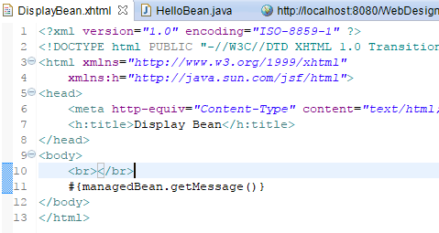

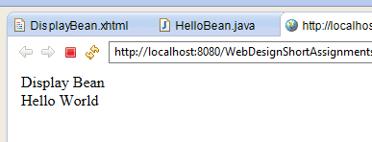

**Servlet Screenshots**

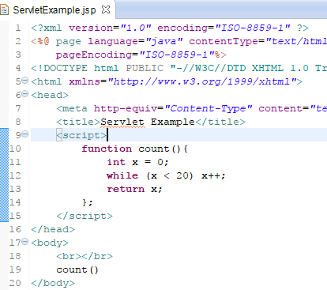

1. Configuration and Library Screenshots

